Name___________________________________. Mark= /

|  |  |  |
| --- | --- | --- |
| Test part | Possible mark | Your mark |
| Multiple choice | 25 |  |
| Short answer | 41 |  |
| Total | 66 |  |

Nervous System Topic Test Name___________________________________. Mark= /

Name___________________________________. Mark= /

Name___________________________________. Mark= /

***Multiple choice answer sheet.* Use a ball point or ink pen to mark an X** on the letter that represents the best answer from the choice of answers. Marks are not deducted for wrong answers.

|  |  |  |  |
| --- | --- | --- | --- |
| Question | Answer | Question | Answer |
| 1 | A B C D | 11 | A B C D |
| 2 | A B C D | 12 | A B C D |
| 3 | A B C D | 13 | A B C D |
| 4 | A B C D | 14 | A B C D |
| 5 | A B C D | 15 | A B C D |
| 6 | A B C D | 16 | A B C D |
| 7 | A B C D | 17 | A B C D |
| 8 | A B C D | 18 | A B C D |
| 9 | A B C D | 19 | A B C D |
| 10 | A B C D | 20 | A B C D |
|  | | 21 | A B C D |
| 22 | A B C D |
| 23 | A B C D |
| 24 | A B C D |
| 25 | A B C D |

1. The cerebellum is concerned with _______________.
2. conditioning
3. memory
4. coordination and precision movement.
5. intelligence
6. At the synapses, the impulses are always passed from the:
7. axon to the dendrites
8. dendrites to the axon
9. either way is possible
10. cyton to the dendrites
11. The medulla oblongata is best described as:
12. A structure in the cerebrum that contains the cardiac, respiratory, vomiting and vasomotor centers and deals with autonomic functions, such as breathing, heart rate and blood pressure.
13. A structure in the brain stem that contains the cardiac, respiratory, vomiting and vasomotor centers and deals with autonomic functions, such as breathing, heart rate and blood pressure.
14. A structure in the brain stem that controls water balance and hormone production.
15. A structure in the cerebellum that contains neurons concerned with memory.
16. Which of the following statements is correct?
17. In the spinal cord and brain the grey matter is to the outside.
18. In the spinal cord the grey matter is to the outside. In the brain the white matter is to the outside.
19. In the spinal cord the white matter is to the outside. In the brain the grey matter is to the outside.
20. There is no grey matter in the spine.
21. Which of the following statements about Schwann cells is correct?
22. Schwann cells help form the myelin sheath.
23. Schwann cells are not found in the white matter.
24. Schwann cells are only found in the grey matter.
25. Schwann cells are only found on sensory neurons.
26. The most obvious difference between the human brain and the brain of a fish would be in the:

A. hypothalamus.

b. thalamus.

c. cerebellum.

d. cerebral cortex.

1. An elderly acquaintance of yours has suffered from partial blindness since she had a stroke. Apparently the stroke damaged her

a. occipital lobe.

b. parietal lobe.

c. temporal lobes.

d. reticular formation.

1. Which of the following changes would you expect to occur in someone whose frontal lobes were damaged in an accident?

a. development of blank spots in the visual field

b. reduced capacity to hear high frequency sounds

c. reduced reasoning and planning abilities and changes in personality

d. inability to demonstrate complex motor skills

1. At the point where a neuron stimulates a muscles neurotransmitters receptors are located in the:
2. Dendrites
3. Synaptic cleft
4. Sarcolemma
5. Actin and myosin
6. Which of the following is not found in the Cerebrospinal fluid?
7. Urea
8. White blood cells
9. Glucose
10. Acetylcholine
11. The surface area of the cerebral cortex is:
12. Increased by folds.
13. Increased by pressure excerted by the cerebrospinal fluid.
14. Decreased by folds.
15. Decreased by pressure excerted by the cerebrospinal fluid.

Use the following graph to answer questions 12 and 13.

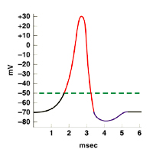

1. During which time period are sodium gates open?
2. 1 to 2 msec.
3. 2 to 3 msec.
4. 3 to 4 msec.
5. 4 to 5 msec.
6. What is the resting potential for this neuron?
7. -70mV
8. -50mV
9. +30mV
10. 15mV
11. What is the threshold potential in the graph above?
12. -70mV
13. -50mV
14. +30mV
15. 15mV
16. A reflex arc response contributes to homeostasis by:
17. Keeping body temperature constant.
18. Keeping the ion balance constant in the body fluids.
19. Keeping the middle ear sensory neurons constant.
20. Preventing serious injury.

Use the diagram below to answer question 16, 17 and 18.

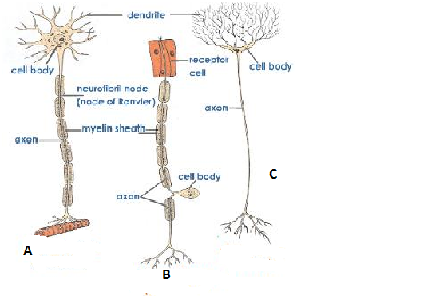

1. Which of the neurons above is more likely to be found in the grey matter of the cerebral cortex?
2. A
3. B
4. C
5. A and B
6. Which neuron/s above will display salutatory conduction?
7. A
8. B
9. C
10. A and B
11. Which of the following best matches the neurons shown with its functional classification?

|  |  |  |  |  |
| --- | --- | --- | --- | --- |
|  |  | Neuron Functional classification | | |
| Answer choice | Neuron | **A** | **B** | **C** |
| a |  | Motor | Interneuron/transfer neuron | Sensory |
| b |  | Interneuron/transfer neuron | Motor | Sensory |
| c |  | Interneuron/transfer neuron | Sensory | Motor |
| d |  | Motor | Sensory | Interneuron/transfer neuron |

1. The Afferent division of the peripheral nervous system can be divided into:
2. The sympathetic and parasympathetic nervous systems.
3. The efferent and divergent nervous systems.
4. The somatic sensory and visceral sensory systems.
5. The somatic division and autonomic motor divisions.
6. Which of the following statement about the autonomic nervous system are correct?
7. It is part of the Efferent division of the peripheral nervous system. It attempts to maintain homeostasis and is divided into two parts (sympathetic and parasympathetic).
8. It is an integral part of the central nervous system, within conscious control and automated in its responses.
9. It is part of the Afferent division of the peripheral nervous system. It uses shared somatic pathways to maintain homeostasis.
10. It has two ganglia between its origin and its point of delivery and has no need of neurotransmitters.
11. The somatic neural pathway uses:
12. Acetylcholine or noradrenaline as neurotransmitters.
13. Acetylcholine as a neurotransmitter.
14. Noradrenaline as a neurotransmitter.
15. Acetylcholinerase as a neurotransmitter.
16. The arachnoid area of the middle layer of the meninges:
17. Has spaces containing Cerebrospinal that along with bone protect the brain from impact.
18. Has spaces containing neurotransmitters that along with bone protect the brain from sudden impact.
19. Contains many large blood vessels that supply the brain with oxygen rich blood.
20. Contains synovial fluid to reduce friction between the brain and the inside of the skull.

Use the diagram below to answer question 23.

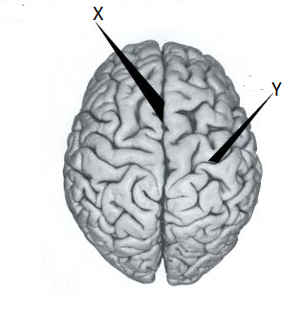

1. The structures in the diagram are:

|  |  |  |
| --- | --- | --- |
| Answer | **X** | **Y** |
| a | Sulcus | Central fissure |
| b | Central fissure | Sulcus |
| c | Gyrus | Central fissure |
| d | Sulcus | Gyrus |

Use the diagram below to answer question 24.

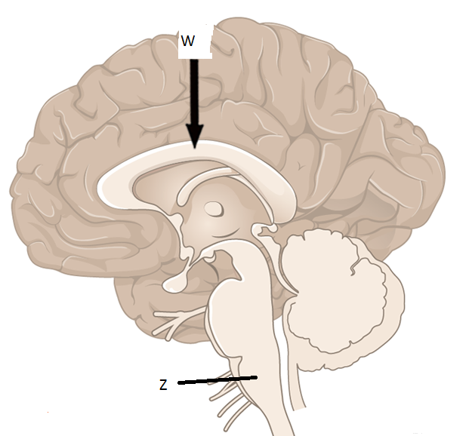

1. Look at the structures above and choose the correct name and function of W.

|  |  |  |
| --- | --- | --- |
| Answer | Name | Function |
| A | Cerebral cortex | Does visual processing |
| B | Medulla oblongata | Cardiac and respiratory control |
| C | Corpus callosum | Allows communication between he left and right hemispheres |
| D | Corpus callosum | Is responsible for Auditory interpretation |

1. In the diagram damage to structure Z is likely to:
2. Be life threatening.
3. Cause deafness.
4. Alter fine muscle control.
5. Cause confusion.

Short answer questions

1. The brain is made up of many neurons with an extensive network of blood vessels. These blood vessels supply the neurons with a constant supply of glucose and oxygen.

State a reason for high demand for glucose and oxygen.

______________________________________________________________________________________________________________________________________________________________________________________________________________________________________________________________________________________________________________________________________________________________________________________________________

______________________________________________________________________________________________________________________________________________________________________________________________________________________________________________________________________________________________________________________________________________________________________________________________________

______________________________________________________________________________________________________________________________________________________________________________________________________________________________________________________________________________________________________________________________________________________________________________________________________

1. marks)
2. Label the diagram below and use it to answer the questions that follow.

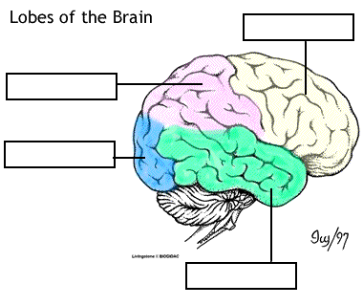

(4 marks)

II. Based on the previous diagram complete the table below.

|  |  |
| --- | --- |
| Functional area | Lobe of brain that the area is located in |
| Sensory |  |
| Movement |  |
| Personality |  |
| Vision |  |
| Smell |  |

(5 marks)

3. Use this diagram to answer the question that follows.

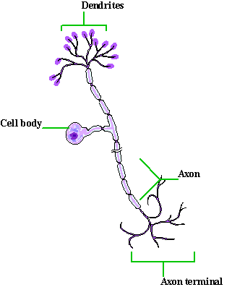

Using morphological classification, what type of cell is shown in the diagram above? Give a reason for your answer.

______________________________________________________________________________________________________________________________________________________________________________________________________________________________________________________________________________________________________________________________________________________________________________________________________

1. marks)

4. a. The diagram below show a nerve synapse. Label all the important structures.

(6 marks)

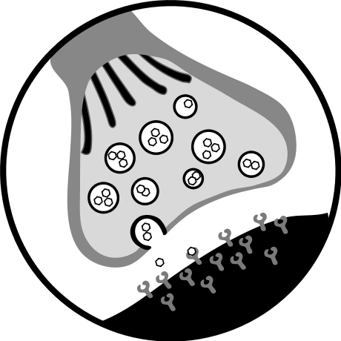

b. In point form explain how a nerve impulse travels across the synapse.

________________________________________________________________________________________________________________________________________________________________________________________________________________________________________________________________________________________________________________________________________________________________________________________________________________________________________________________________________________________________________________________

________________________________________________________________________________________________________________________________________________________________________________________________________________________________________________________________________________________________________________________________________________________________________

(6 marks)

5. a. The diagram below shows a cross-section of the spinal cord. Label the diagram below.

1. marks)

[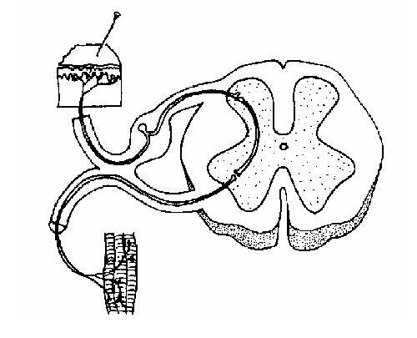](http://wikieducator.org/File:Spinal_nervous_pathway_unlabelled.JPG)

b. state an afferent structure and an efferent structure in the diagram above.

(2 marks)

_________________________________________________________________________________________________________________________________________________________________________________________________________________________________

c. In point form describe what happens in reflex arc like the one above.

________________________________________________________________________________________________________________________________________________________________________________________________________________________________________________________________________________________________________________________________________________________________________________________________________________________________________________________________________________________________________________________________________________________________________________________________________________________

(5 marks)